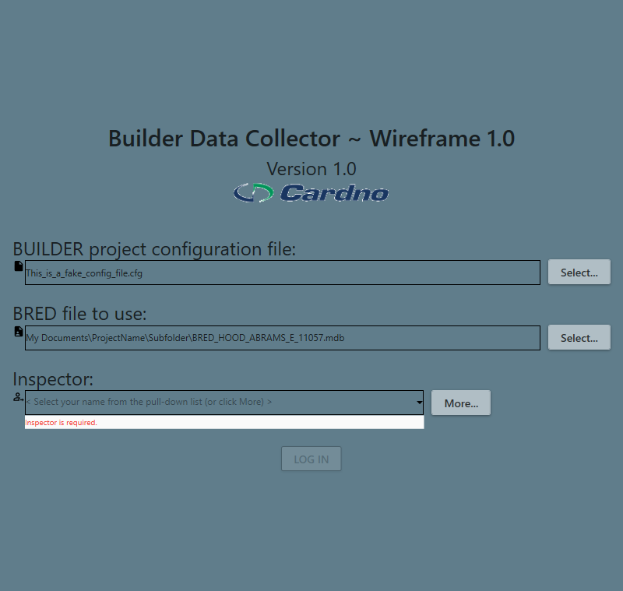

* 1st line: Builder needs to be all cap: BUILDER Data Collector
* Logo edges look bad. In email I have attached 3 alternatives to try. Be sure to maintain aspect ratio.
* Can we drop all the wasted space on top and bottom, have the soft gray background and (Cardno) dark blue border as seen in the wireframe Login tab?: R25 G54 B97 = #193661

Try to get it closer to this:

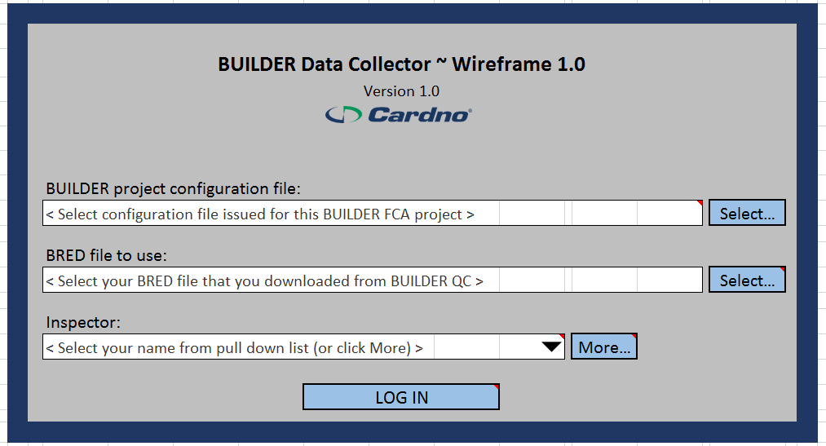

* The icons in front of the three text boxes are too small to look good; Either get them bigger or remove.
* The text in the text boxes is too small as well as the 'Inspector is required' message, larger font please.
  + To note: It is possible that the BRED file to use line can get long; That text box should be auto wrap and expand to two lines of height as needed so the full path and file name can be seen.

## MAIN MENU AND FACILITY TAB

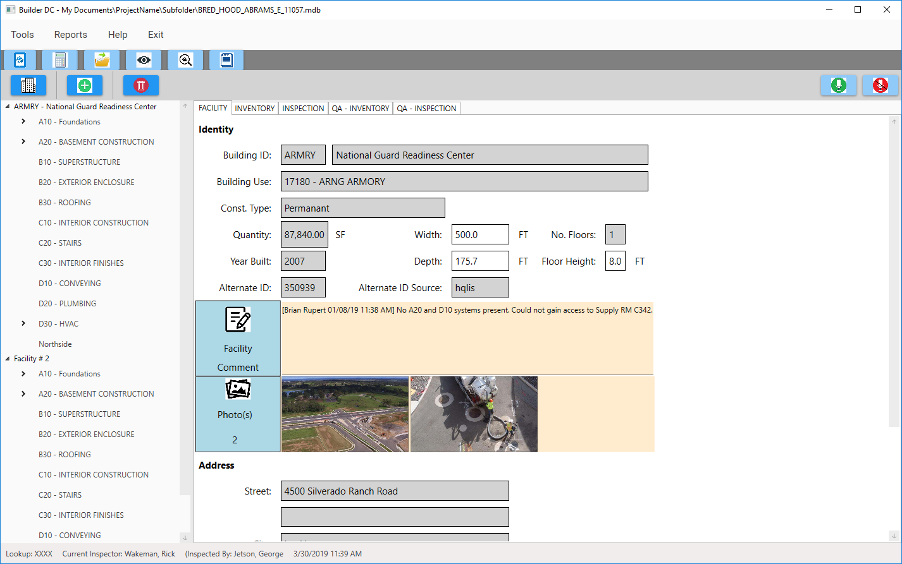

I have supplied you with six new PNG icons to use, see notes below

Need vert. space between Facility comment section and Photo(s) (see wire frame)

Need vert. space between alt ID and Facility comment section (see wire frame)

Not sure if we will go this route of displaying the submenu items also toolbar style, I envisioned these much-less used functions to only be under the menu. Let's see how we do on space and review approach later.   
For these to be functional they need a) more space between them and b) more separation space from the toolbar

* Window Title bar: Are we able to make this font slightly larger , say 20%?
* Menu font: larger font, let's try larger by 20% or so. (I like the extra spacing)
* Toolbar row of icons: I like their spacing between them, but need more space above and below to avoid users tapping tree item (or sub menu items above, if we keep them)
* Building icon (for Inventory Mode): I was envisioning that BOTH this one and the Inspection icon would be displayed, with the currently-active one of the two somehow conveying that… perhaps a black border like this:  
   Inventory Mode  
    
   Inspection Mode  
    
  Thoughts?
* Add System and Delete System icons: As we need to distinguish adding system from adding component from adding Section, I have created three simplistic placeholder PNG files to use as toolbar images. Same thing for delete.
* Text boxes in general: Too much space above and below the text, uses up a lot of valuable vertical space. Can you make that by default for all text boxes more like this:  
  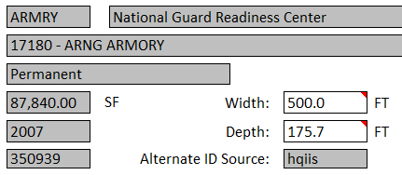
* The text box for Quantity is too small: should accommodate 888,888.88 You can adjust Building ID, Year built and Alternate ID to be the same, as shown in the wire frame.
* Address section: No need for 2nd address line, please remove.

## INVENTORY TAB:

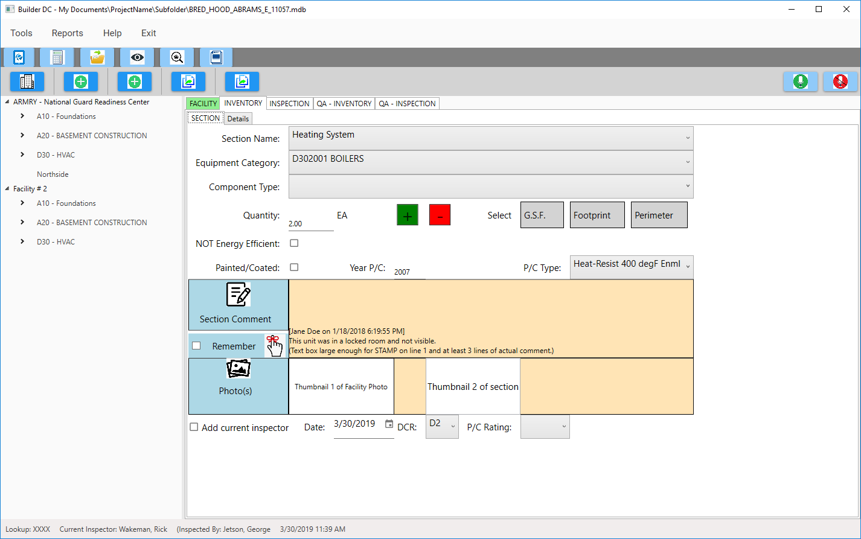

* Supplied you with Add Component and Add Section icons to replace the (identical) placeholders you have used.
* I will work on place holder icons for Copy Section and Copy Inventory.
* Looks like you were in mid point of working on INVENTORY / SECTION SUBTAB, so will not comment much here for now. Some pointers:
* Section Name, Equip Cat and Component Type only need a single line
* The value for DCR Rating are, in order from top to bottom: G+, G G-, Y+, Y, Y-, R+, R, R- (nine possible ratings.
* The same is true for P/C Rating.
* For the photo carrousel row (both for Facility and Inventory (and later on Section)): we can give the photo 'band' more height to have bigger image previews.
* I will comment more when I see your more advanced state after you are closer to the wireframe.

